**24 touch command:** used to create a new file without any content inside it.

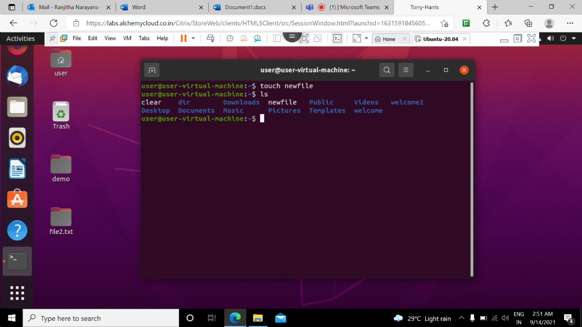

**25 cat command:** Concatenate command reads the data from the file and gives their content as output.

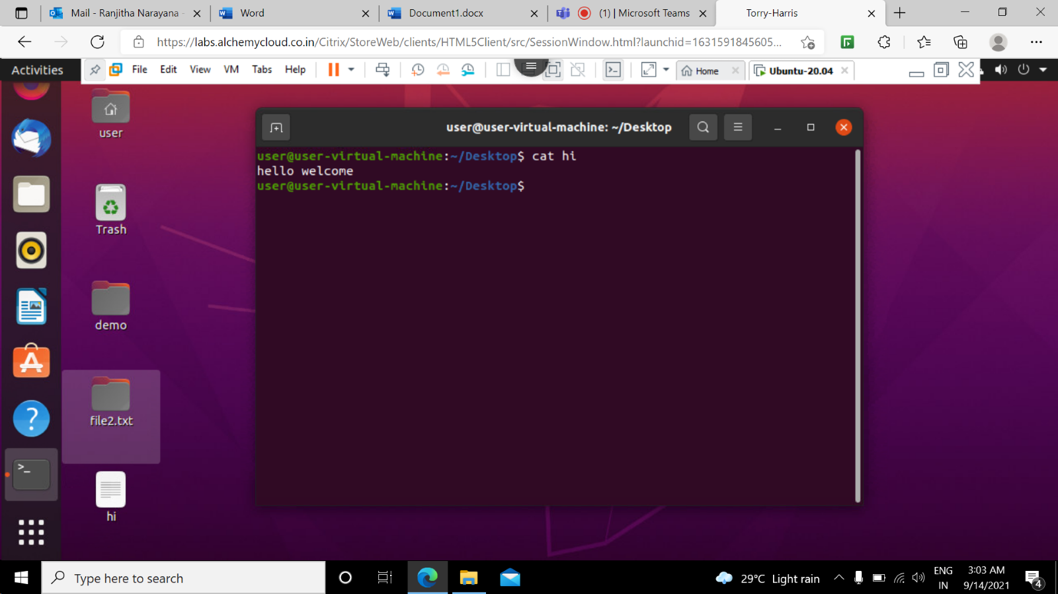

**26 tac command:** This command is used to concatenate and print files in reverse. This command will write each file to standard output, the last line first.

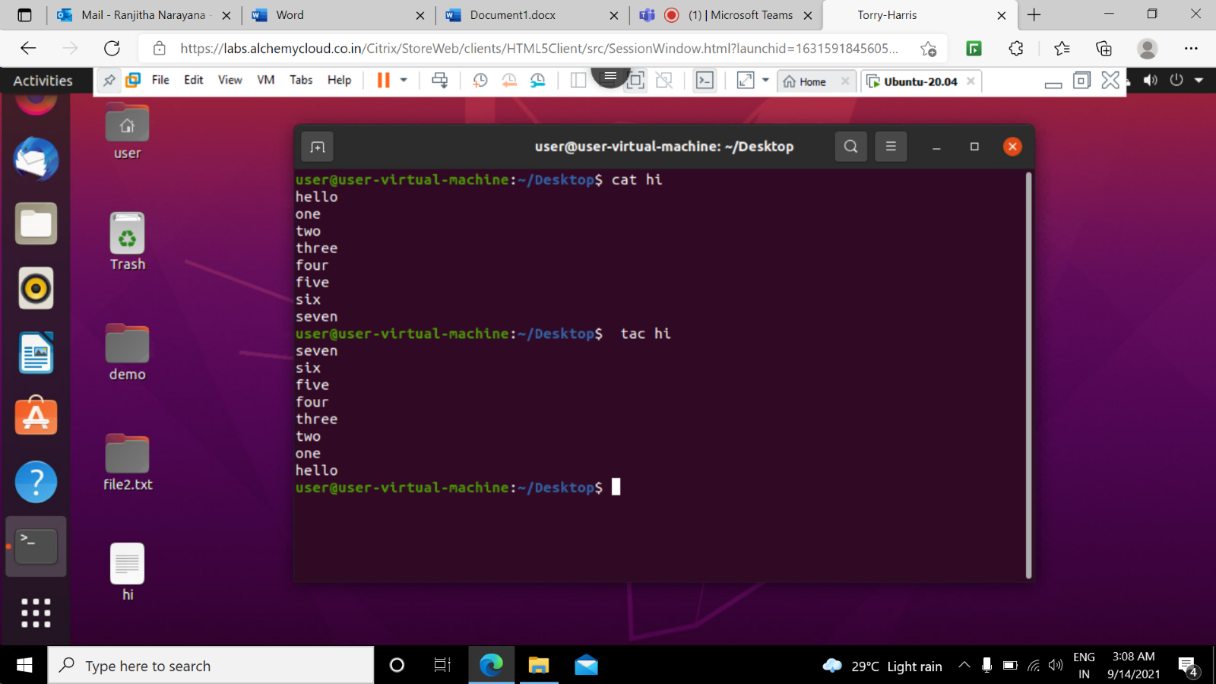

**27 cd / command:** This command is used to change the directory to the root directory.

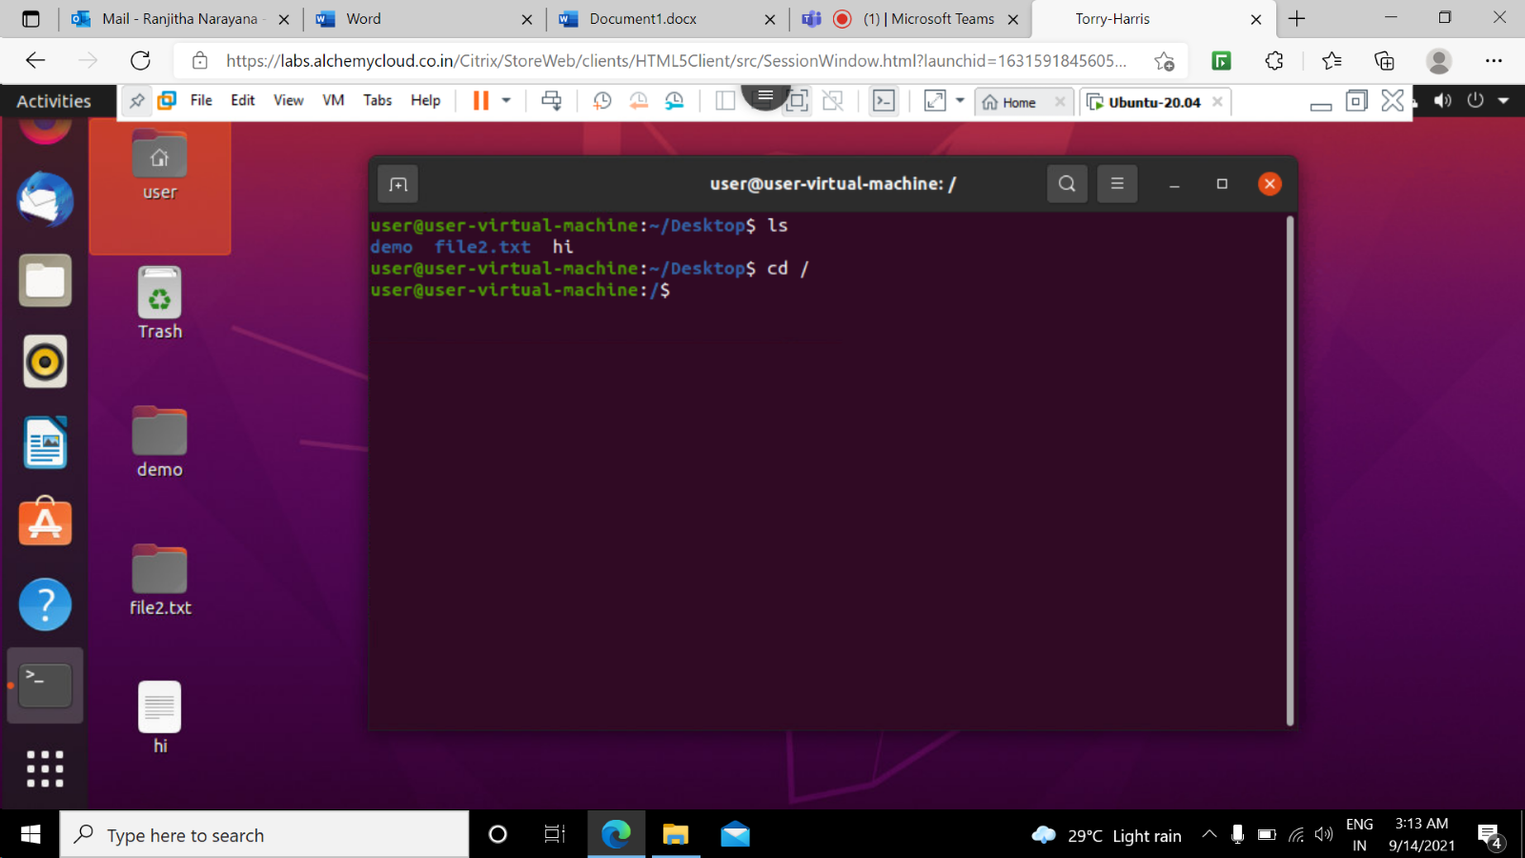

28 sort command: The sort command sorts the file content in an alphabetical order.

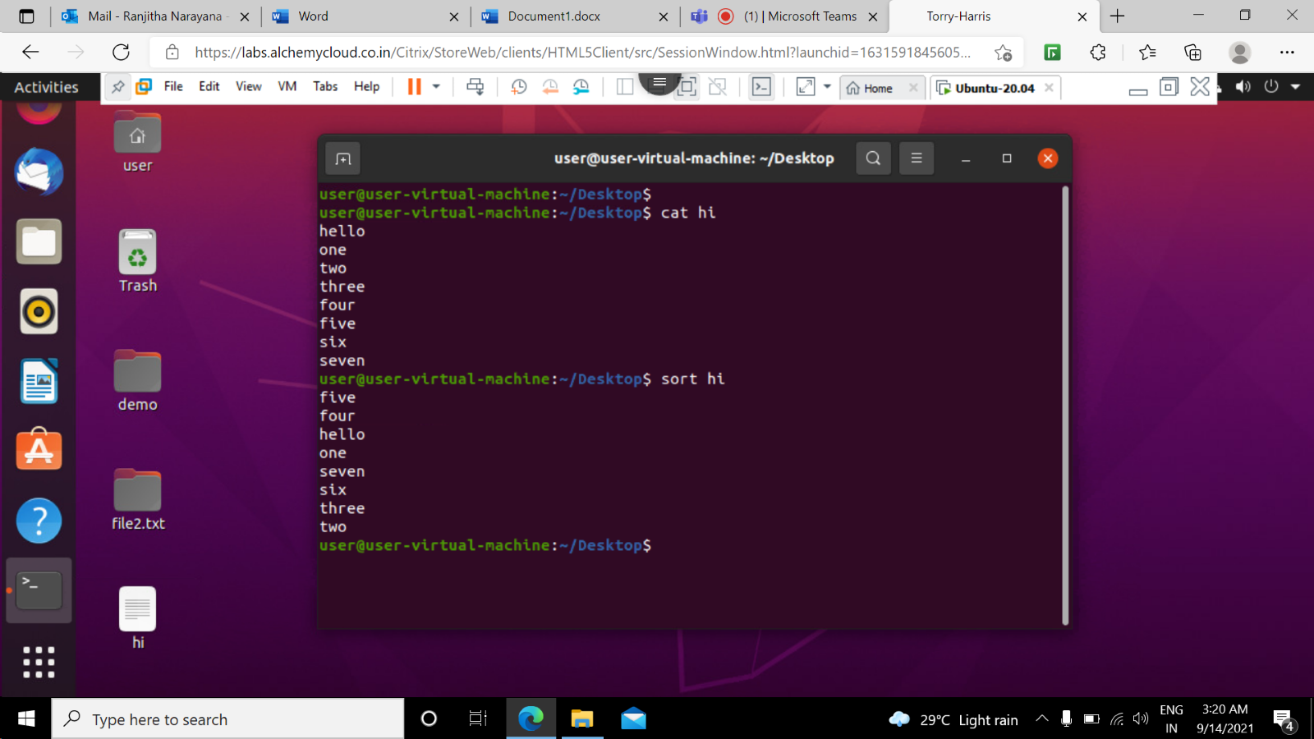

**29 mkdir -p command:** This command is used to create a sub-directories of a directory it will create a parent directory first,if it doesn’t exist.

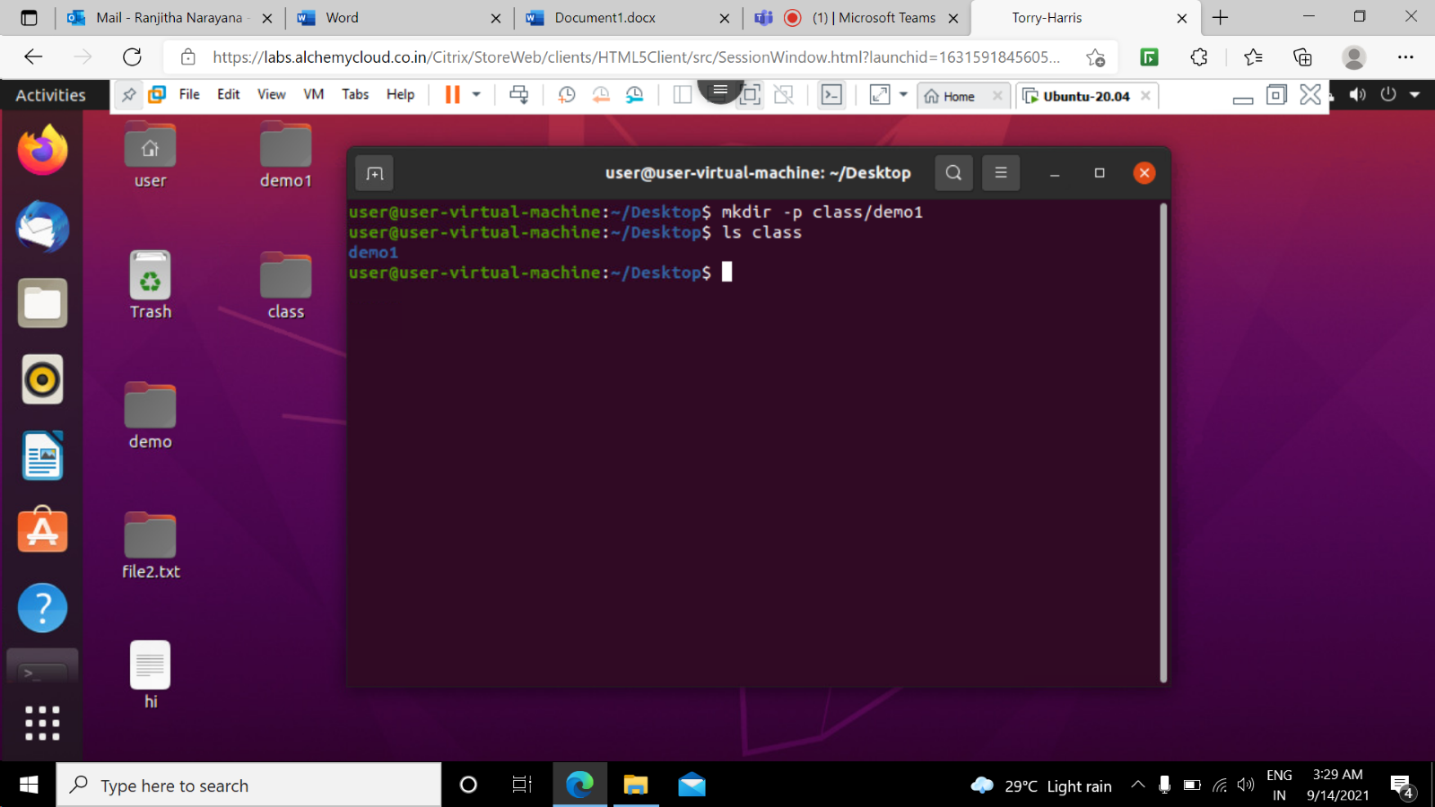

**30 cd . . command:** This command is used to move to the parent directory of current directory or the directory one level up from the current directory.

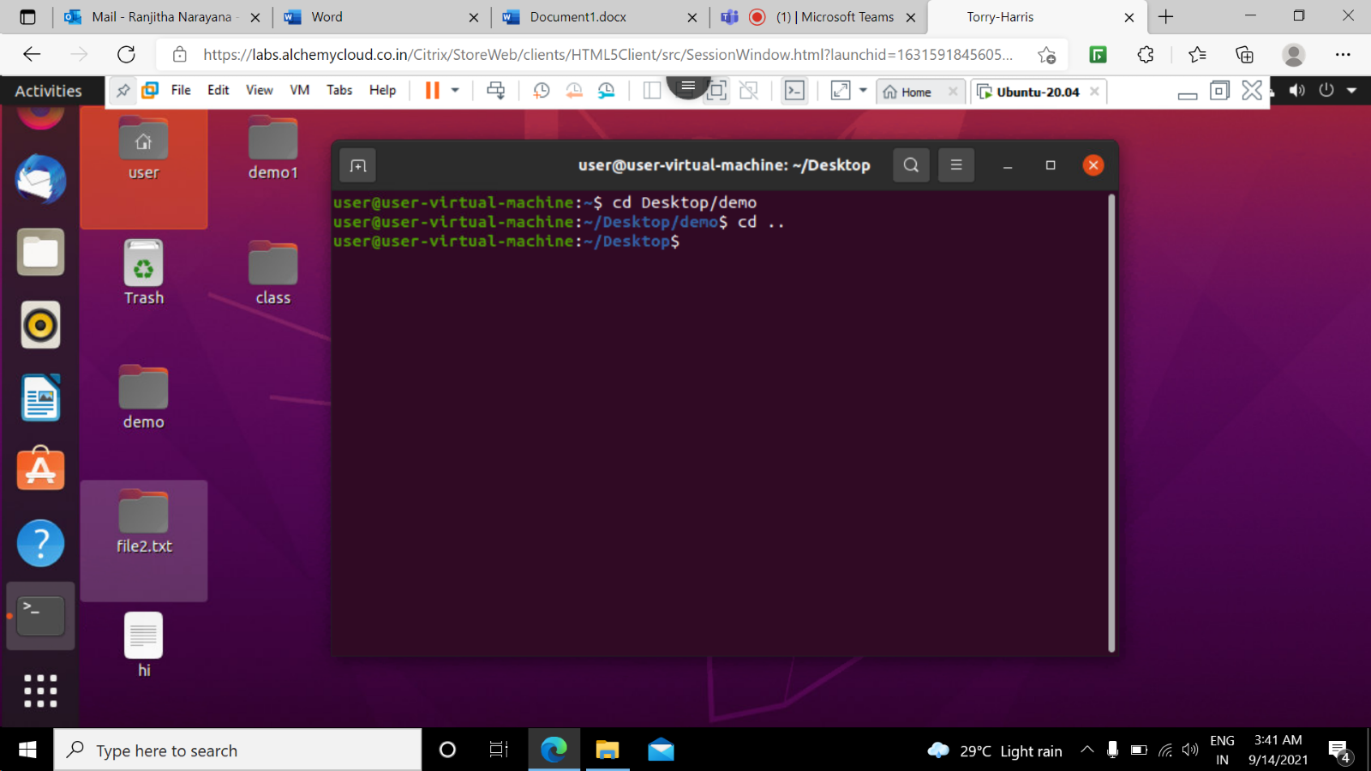

**31 ls -lr command:** This command is used to get the list of directories and files in reverse order.

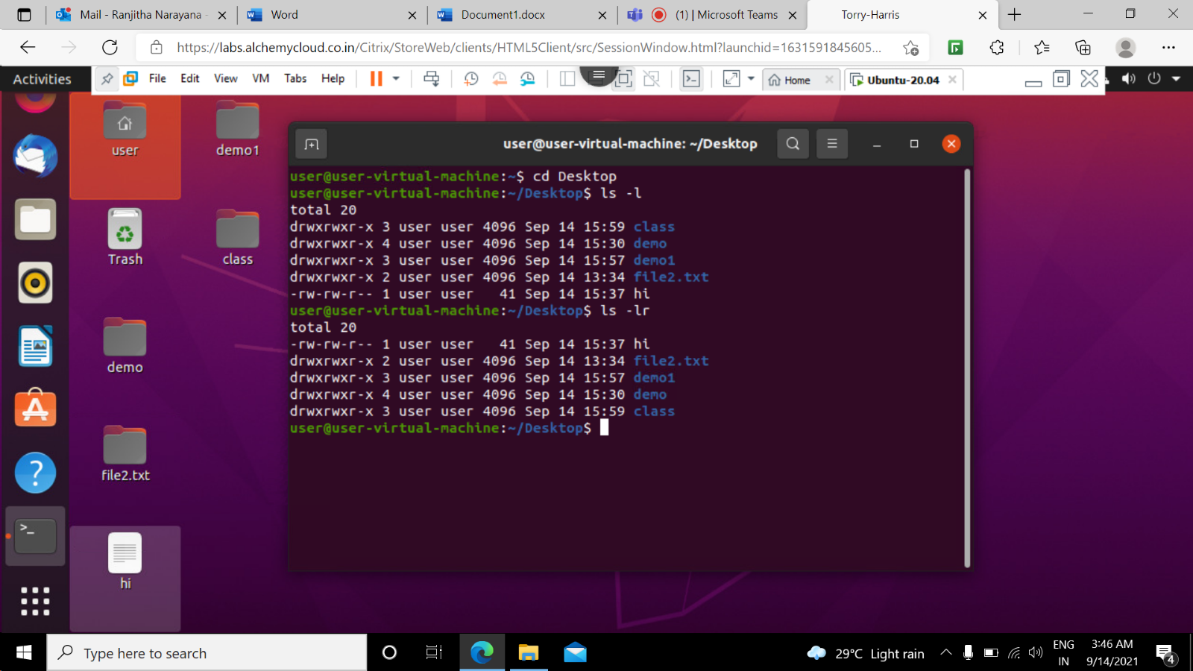

**32 cd ~ command:** This command is used to change directory to the home directory.

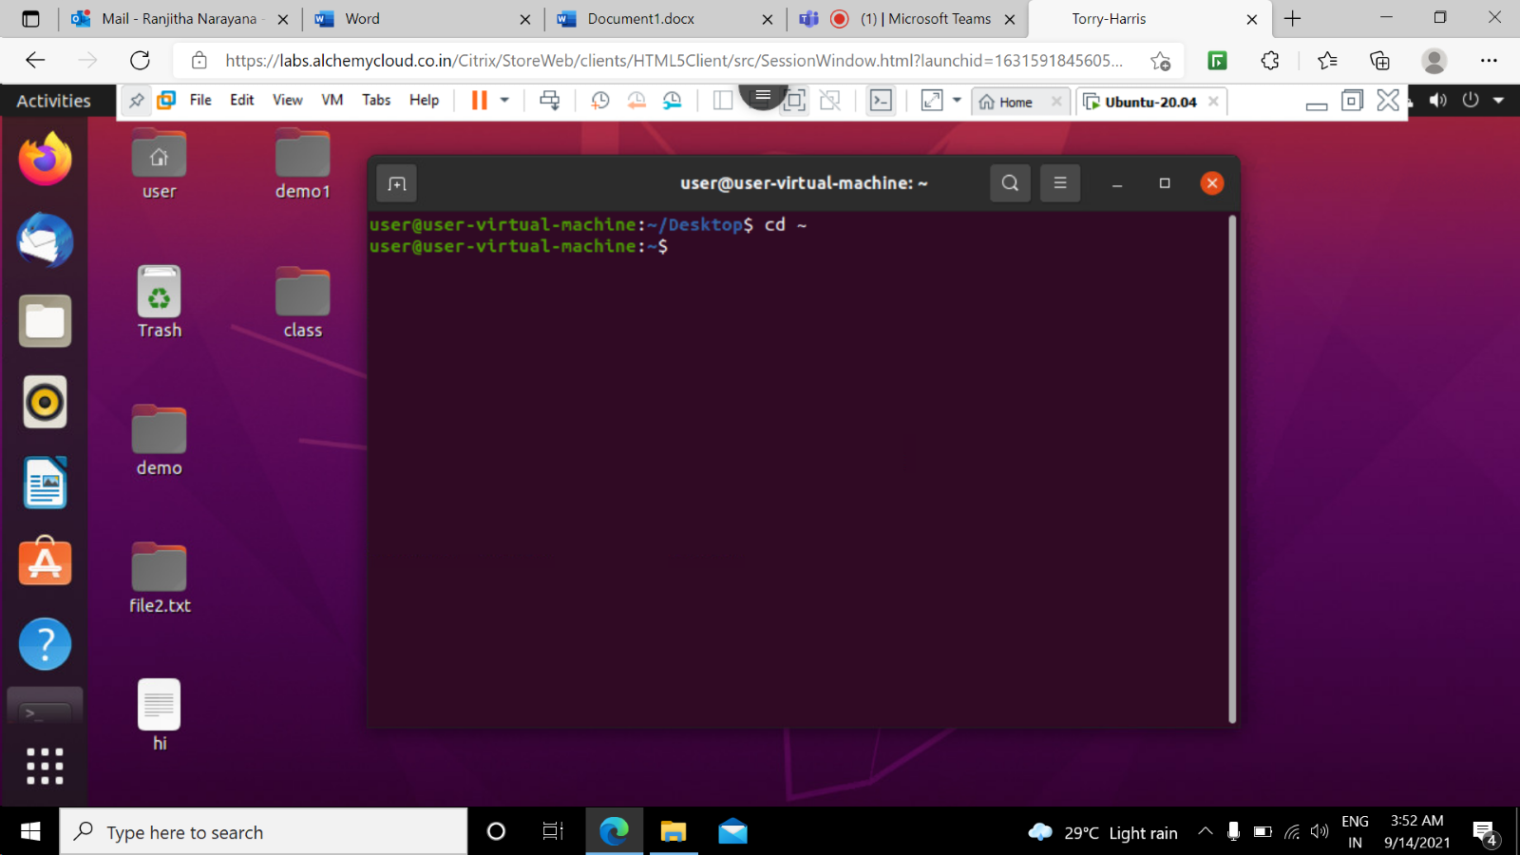

**33 rm -f command:** this command deletes a file forcefully it means a file will be deleted anyhow even if it has read-only permission

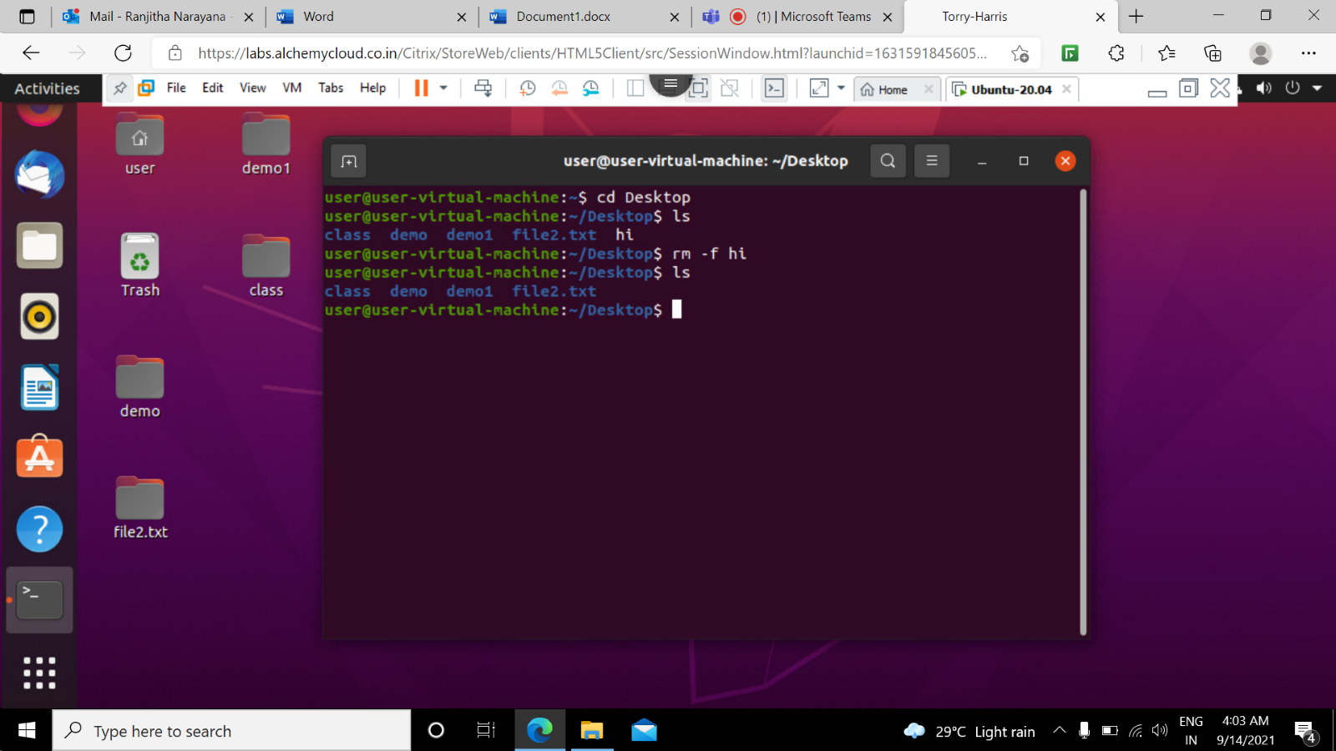

**34 clear command:** This command is used to clear the terminal screen.

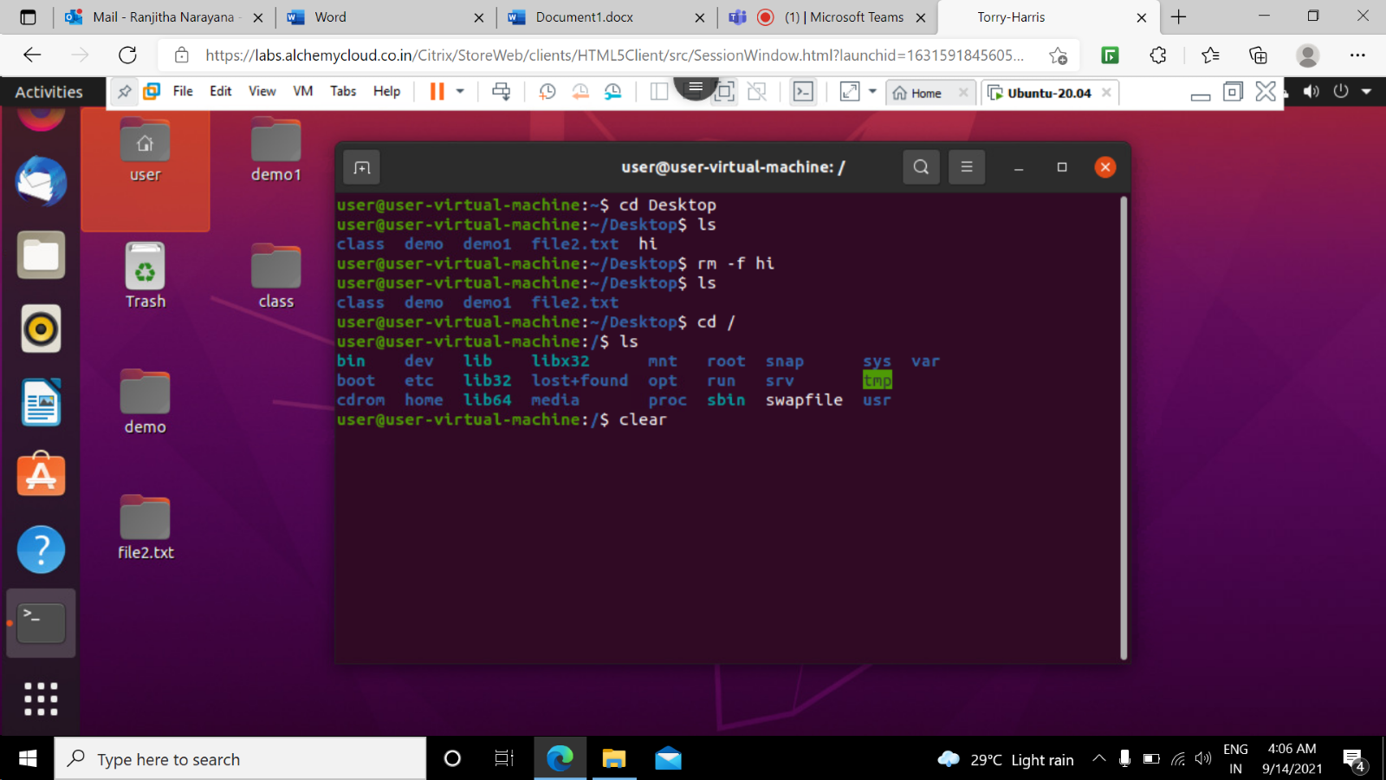

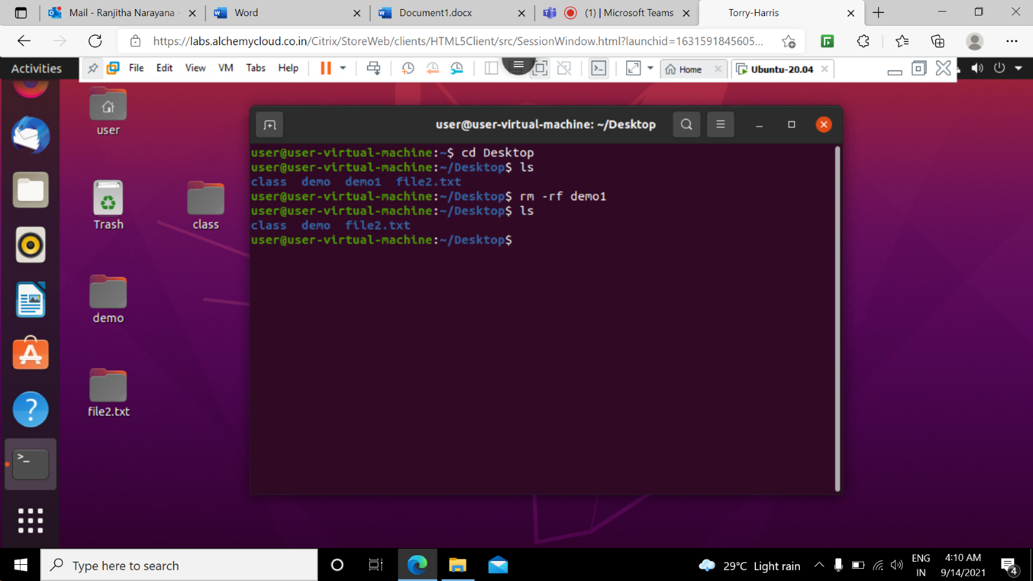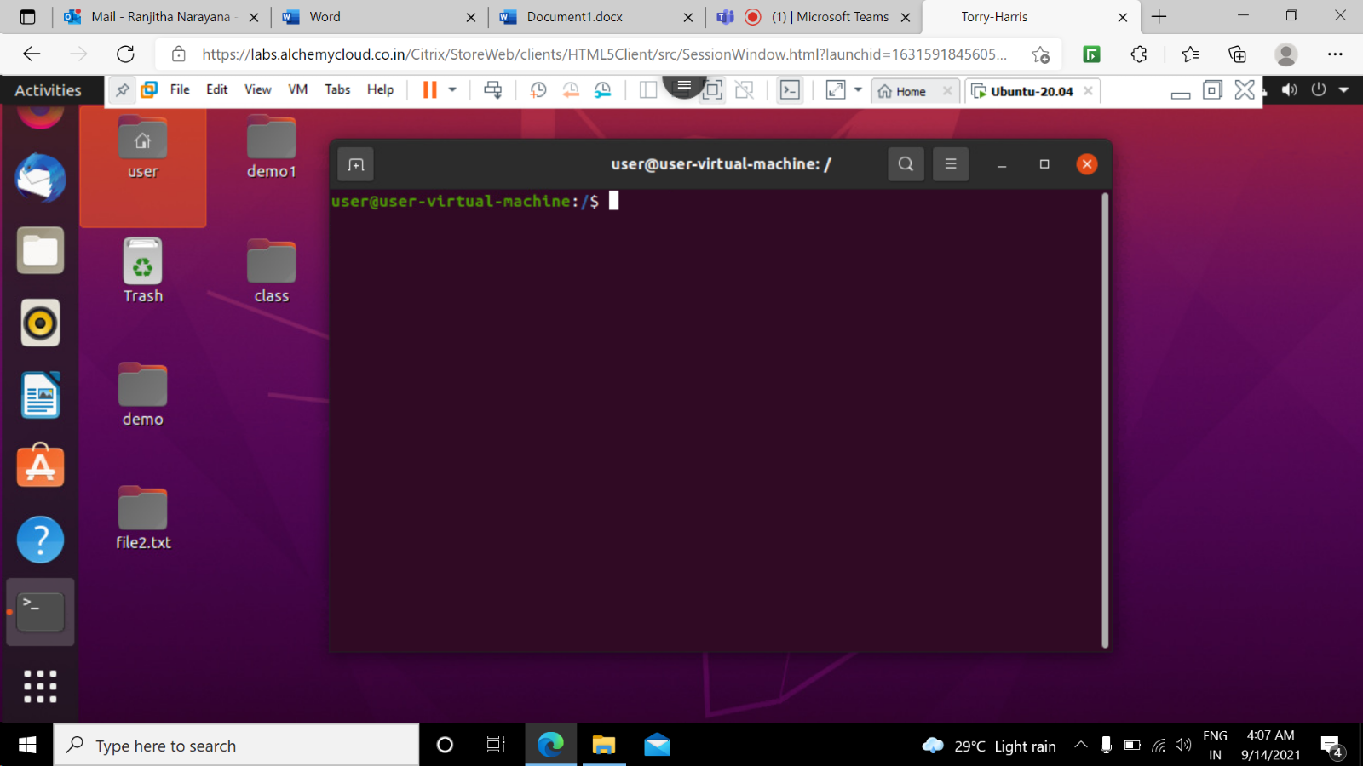

**35 rf -rf command:** This command is used to delete a directory forcefully it means a directory will be deleted anyhow even if it has read-only permission



**36 cat -n command:** This command will show content with line number.

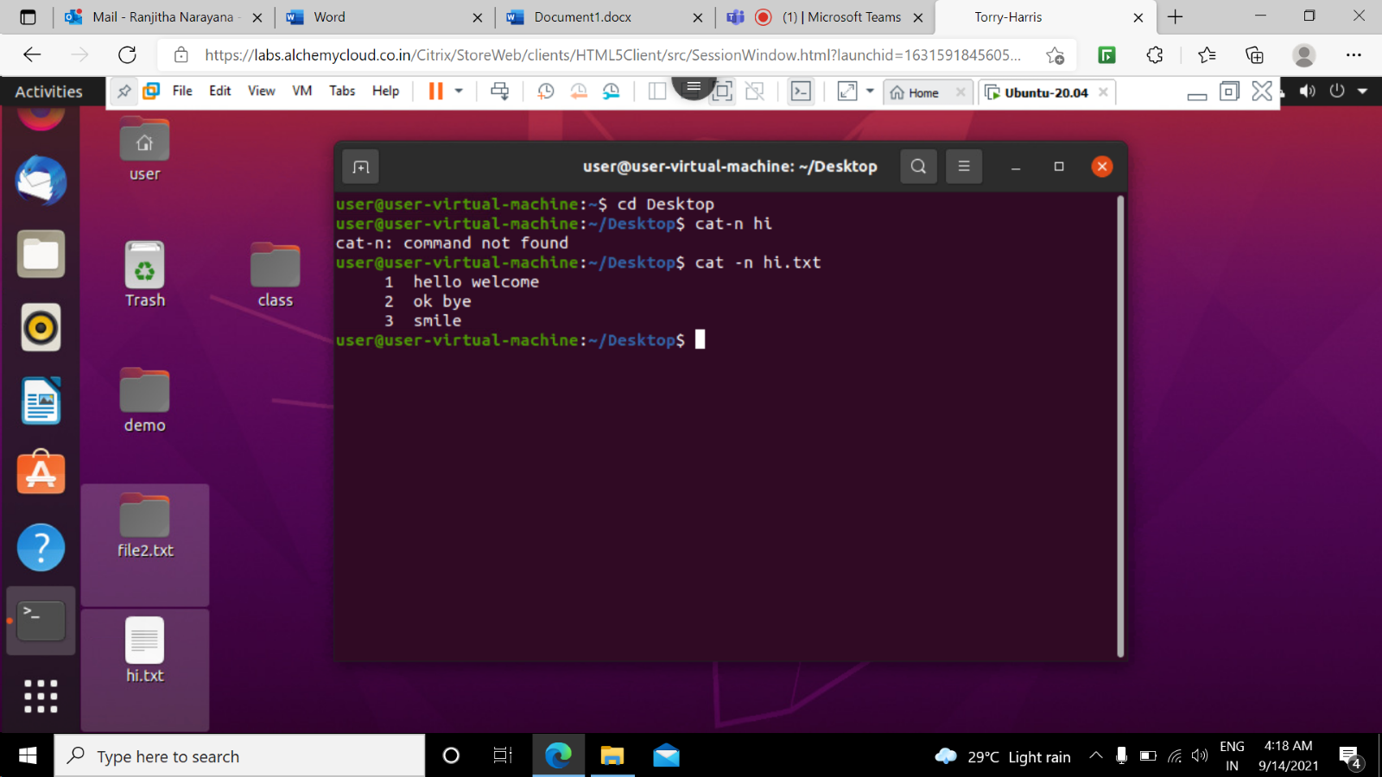

37 **sudo apt-get install command**: This command is used to download the latest version of application.

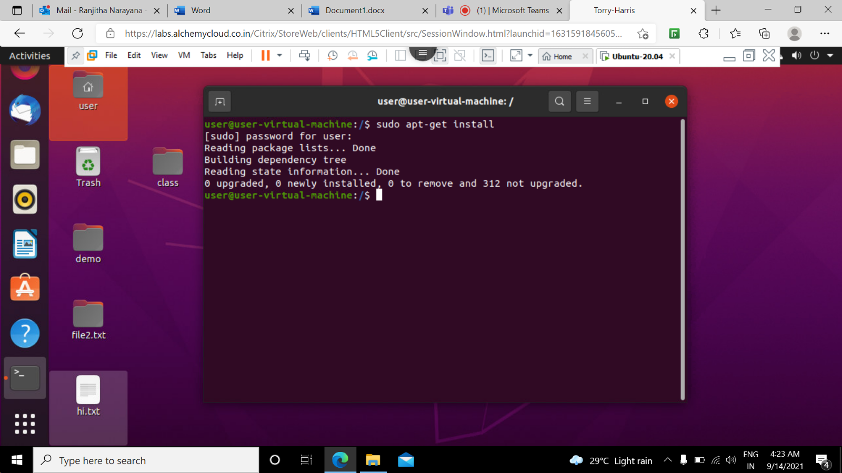

**38 sudo apt-get remove command:** This command is used to remove the binaries but not the configuration or data files of the package

